

Capstone Project Report
Report 3 – Software Requirement Specification

– Ho Chi Minh City, October 2025 –
​​Table of Contents
​
​
​
​
​
​
​
​
​
​
​
​
​
​
​
​
​
​
​
​
​
​
​
​
​
​
​
​
​
​
​​

I. Record of Changes
Date | A*  M, D | In charge | Change Description
*A - Added M - Modified D - Deleted

II. Software Requirement Specification
1. Product Overview
The Learner Management and 3D Simulation System for Crane Training Center (LSSCTC) is an integrated software suite designed to address the high costs, significant safety risks, and logistical challenges of traditional crane operation training. The system provides a unified solution for both theoretical and simulated practical training.

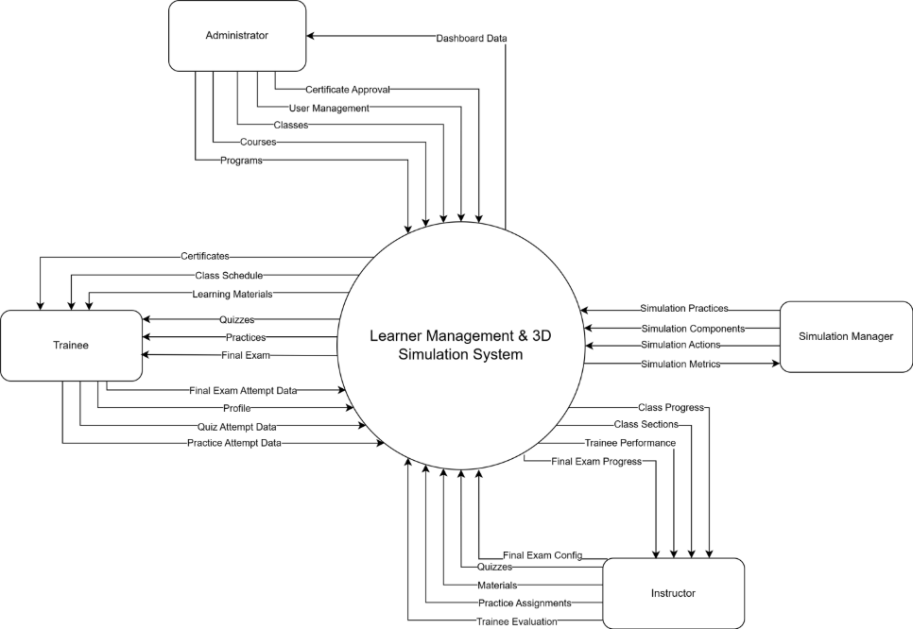

2. User Requirements
2.1 Actors
# | Actor | Description
1 | Administrator | Holds the highest level of authority in the system. This actor consolidates System Administration and Training Management responsibilities.  Duties:  - System Admin: Manages user accounts, roles, and access status (Active/Inactive).  - Training Management: Defines the entire curriculum hierarchy including Programs, Courses, Sections, and Learning Activities.  - Class Management: Creates classes, schedules sessions, and assigns Instructors.  - Certification: Oversees certificate issuance.
2 | Simulation Manager | Responsible for establishing and maintaining technical standards for the 3D simulation environment. This actor manages equipment specifications (Brand, Model), Simulation Components, and constructs practical scenarios (Simulation Practices) by defining specific Tasks and configurations to ensure trainees adhere to correct crane operation procedures.
3 | Instructor | Responsible for delivering training and assessing outcomes. Duties include managing course materials and question banks, conducting classes according to schedule, tracking attendance, grading final exams (Simulated & Practical), and monitoring trainee progress.
4 | Trainee | The primary end-user of the training system. Responsibilities include participating in assigned classes, consuming learning materials (Theory & Simulation), performing practice exercises on the 3D platform, and completing assessments (Quizzes, Final Exams) to obtain certification.

2.2 Use Case
2.2.1 Use Case Diagram

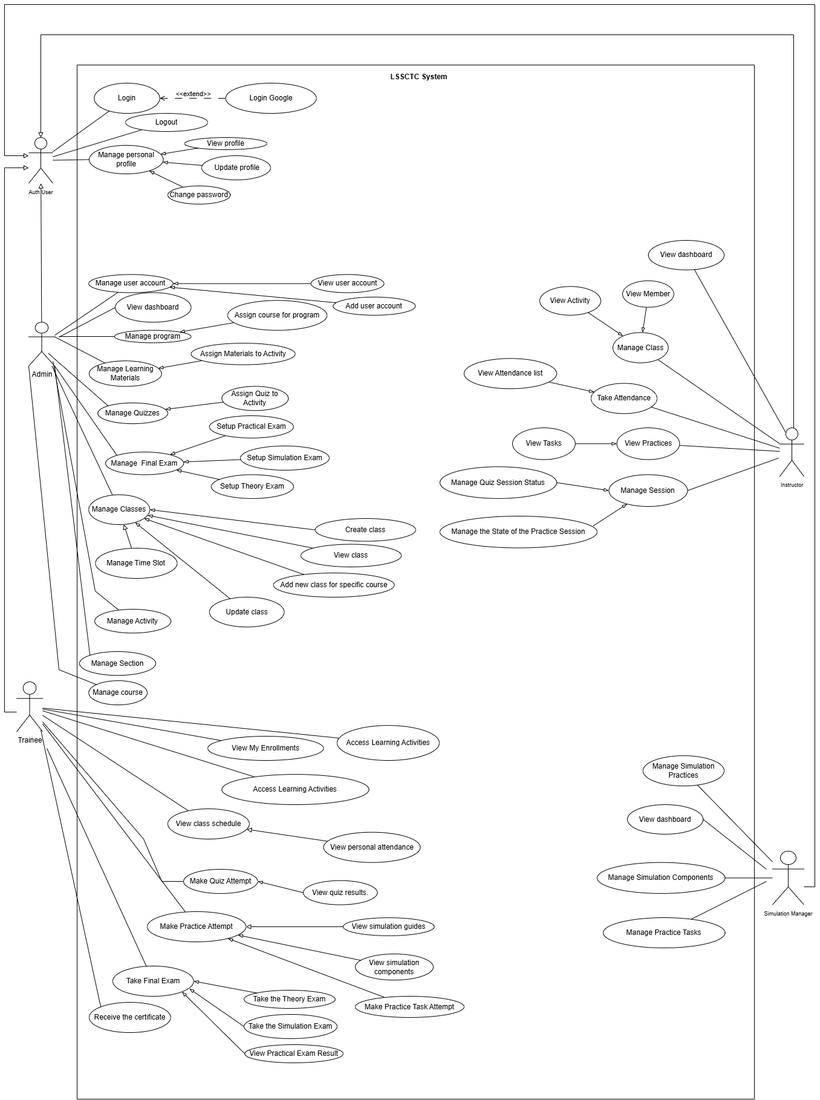

2.2.2 Descriptions
ID | Use Case | Actors | Use Case Description
UC-01 | Login | Auth User | The user enters their registered email and password. The system validates the credentials and, if correct, grants access to the role-specific dashboard. If incorrect, the system displays an error message.
UC-02 | Login Google | Auth User | The user selects the Google login option. The system authenticates the user via Google and grants access only if the email address is already linked to an existing account in the system.
UC-03 | Logout | Auth User | The user chooses to sign out. The system immediately terminates the active session, invalidates access privileges, and redirects the user to the public login screen.
UC-04 | View profile | Auth User | The user accesses the profile section. The system retrieves and displays the user's personal information, contact details (email, phone, address), and role-specific professional data.
UC-05 | Update profile | Auth User | The user edits their editable information (such as phone number or address) or uploads a new profile picture. The system validates the input, saves the changes, and updates the profile display.
UC-06 | Change password | Auth User | The user provides their current password and a new password. The system verifies the current password and, if valid, updates the account credentials with the new password.
UC-07 | Assign Resources | Admin | Admin allocates resources to classes: Assigning Instructors to teaching slots and enrolling Trainees into classes.
UC-08 | View dashboard | Instructor | TThe system displays an overview of the instructor's activities, including total assigned classes, student statistics, and the upcoming teaching schedule.
UC-09 | View Member | Instructor | The instructor selects a specific class. The system retrieves and displays the list of all trainees enrolled in that class with their basic profile information.
UC-10 | View Activity | Instructor | The system displays the course curriculum structure for a class, listing all learning activities (Documents, Videos, Quizzes, and Simulation Practices) organized by sections.
UC-11 | Manage Class | Instructor | The system lists classes assigned to the instructor. The instructor selects a class to access its detailed management interface, including schedule, members, and grades.
UC-12 | View Attendance list | Instructor | The instructor selects a specific class session (time slot). The system displays the attendance records, showing which students were present, absent, or late.
UC-13 | Take Attendance | Instructor | The instructor marks or updates the attendance status (Present/Absent) for students in a specific session. The system saves the attendance records to the database.
UC-14 | View Tasks | Instructor | The instructor views the details of a simulation practice. The system lists the specific tasks and steps that students are required to complete within that simulation.
UC-15 | View Practices | Instructor | The system displays a library or list of simulation practice scenarios associated with the instructor's courses.
UC-16 | Manage Quiz Session Status | Instructor | The instructor changes the state of a quiz (e.g., Open or Locked). The system grants or restricts student access to the quiz based on this status.
UC-17 | Manage Session | Instructor | The instructor selects a teaching slot. The system allows the instructor to view details, update the session topic, or mark the session as completed.
UC-18 | Manage the State of the Practice Session | Instructor | The instructor toggles the status of a simulation practice session. The system enables or disables the "Start Simulation" button for trainees in that class.
UC-19 | View dashboard | Simulation Manager | The system presents a real-time overview of the simulation platform, displaying key metrics such as active concurrent sessions, practice completion rates, and average session duration.
UC-20 | Manage Simulation Practices | Simulation Manager | The Simulation Manager creates, updates, or deletes training scenarios (Practices). The system stores the scenario details, difficulty levels, and configuration settings, making them available for assignment.
UC-21 | Manage Simulation Components | Simulation Manager | The Simulation Manager configures the fundamental assets or technical modules required for the simulation environment. The system maintains a registry of these components to ensure proper functionality during practice sessions.
UC-22 | Manage Practice Tasks | Simulation Manager | The Simulation Manager defines the specific steps and objectives (Tasks) within a Practice. The system organizes these tasks into a sequence that trainees must successfully execute to complete the simulation.
UC-23 | View dashboard | Admin | The system presents a high-level statistical overview, including total users, active courses, recent enrollments, and system health metrics.
UC-24 | Manage user account | Admin | The Admin creates, updates, or deactivates user accounts (Trainees, Instructors, Simulation Managers). The system validates the input and updates the user registry.
UC-25 | View user account | Admin | The Admin filters and selects a specific user. The system displays detailed information, including role, contact details, and account status.
UC-26 | Manage program | Admin | The Admin creates or modifies Training Programs. The system stores the program details (Name, Description, Code) as a container for courses.
UC-27 | Assign course for program | Admin | The Admin links specific Courses to a Program. The system establishes the hierarchy, organizing the curriculum under the selected program.
UC-28 | Manage course | Admin | The Admin creates or edits a Course (e.g., "Crane Operation Basics"). The system saves the course metadata and prepares it for content structure.
UC-29 | Manage Section | Admin | The Admin defines the structure within a Course (e.g., "Module 1", "Week 2"). The system organizes these sections sequentially to hold learning activities.
UC-30 | Manage Activity | Admin | T The Admin adds learning items (Videos, Documents, Quizzes) into a Section. The system links the resource to the course structure.
UC-31 | Manage Learning Materials | Admin | T The Admin uploads or updates educational resources (PDFs, Videos). The system stores these assets in a central library for assignment.
UC-32 | Assign Materials to Activity | Admin | T The Admin selects a specific material (e.g., a PDF) and links it to a Course Activity. The system makes the material accessible to trainees enrolled in that course.
UC-33 | Manage Quizzes | Admin | T The Admin creates quiz questions and defines settings (time limit, passing score). The system stores the quiz bank.
UC-34 | Assign Quiz to Activity | Admin | The Admin links a specific Quiz to a Course Activity. The system configures the activity to trigger the selected assessment when accessed.
UC-35 | Manage Classes | Admin | TThe Admin views a list of all classes. The system allows filtering by course or status and provides options to create or modify class instances.
UC-36 | Create class / Add new class for specific course | Admin | The Admin instantiates a specific Course into a Class (e.g., "Class A for Course 1"). The system generates the class record, inheriting the course's content structure.
UC-37 | View class | Admin | The Admin selects a class. The system displays comprehensive details including the instructor, enrolled trainees, schedule, and current progress.
UC-38 | Update class | Admin | TThe Admin modifies class details such as the assigned instructor, capacity, or status. The system updates the class record.
UC-39 | Manage Time Slot | Admin | The Admin defines specific dates and times for class sessions. The system generates the calendar schedule for the class.
UC-40 | Manage Final Exam | Admin | T The Admin configures the final assessment for a class. The system aggregates the Theory, Practical, and Simulation components into a single exam entity.
UC-41 | Setup Theory Exam | Admin | TThe Admin selects a specific Quiz to serve as the theoretical portion of the Final Exam. The system assigns the weight and passing criteria for this part.
UC-42 | Setup Practical Exam | Admin | The Admin configures the grading checklist or rubric for the physical crane operation test. The system prepares the evaluation form for instructors.
UC-43 | Setup Simulation Exam | Admin | TThe Admin selects a specific Simulation Scenario to serve as the virtual assessment. The system links the scenario to the Final Exam logic.
UC-44 | View My Enrollments | Trainee | T The system displays a list of courses and classes the trainee has been registered for. It shows the current status (Ongoing, Completed, or Drop-out) and progress percentage for each class.
UC-45 | View Class Schedule | Trainee | T The trainee views the weekly timetable. The system displays specific time slots, room locations (or online links), and the attendance status (Present/Absent/Not Started) for each session..
UC-46 | Access Learning Activities | Trainee | The trainee navigates through the course curriculum (Sections). The system provides access to various learning resources including video lectures, PDF documents, and practice links specific to the current module.
UC-47 | Attempt Quiz | Trainee | The trainee starts a theory assessment. The system enforces a timer, presents questions, records answers, and calculates the score immediately upon submission (unless manual grading is required).
UC-48 | Perform Simulation Practice | Trainee | The trainee launches the 3D crane simulation. The system loads the environment, displays step-by-step guides and objectives (Tasks). The system tracks the trainee's inputs and physics interactions in real-time to grade the attempt.
UC-49 | View Personal Attendance | Trainee | The trainee accesses the attendance report. The system calculates and displays the total attendance percentage and lists specific dates of absence to help the trainee track their eligibility for the final exam.
UC-50 | Take Final Exam | Trainee | The trainee enters the final assessment mode. The system validates eligibility, locks the browser (if configured), and presents the Theory Quiz and Simulation Scenario required for course completion.
UC-51 | View Final Result | Trainee | TThe trainee views the comprehensive grade of the Final Exam, which aggregates scores from the Theory test, Simulation test, and the Instructor-graded Practical (physical) test.
UC-52 | Receive Certificate | Trainee | T Upon successful completion of a course/program, the system generates a digital certificate. The trainee can preview and download this certificate as a PDF file.

3. Functional Requirements
3.1 System Functional Overview

3.1.1 Screens Flow
3.1.1.1 Admin Flow
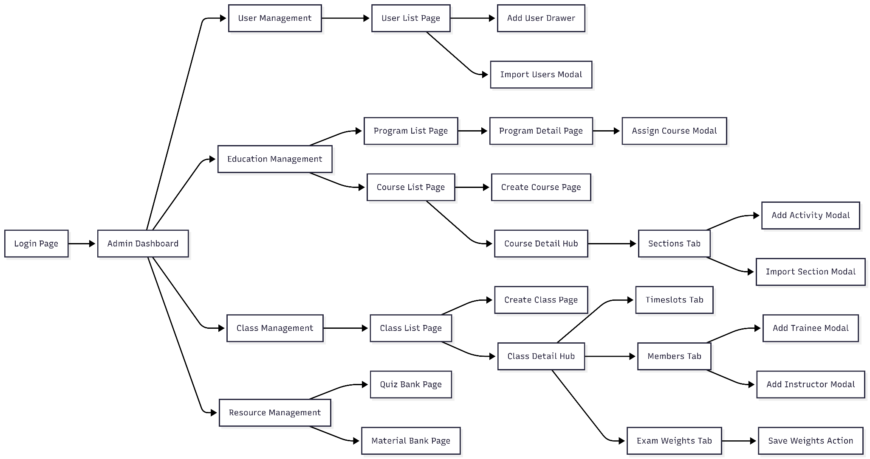

3.1.1.2 Trainee Flow
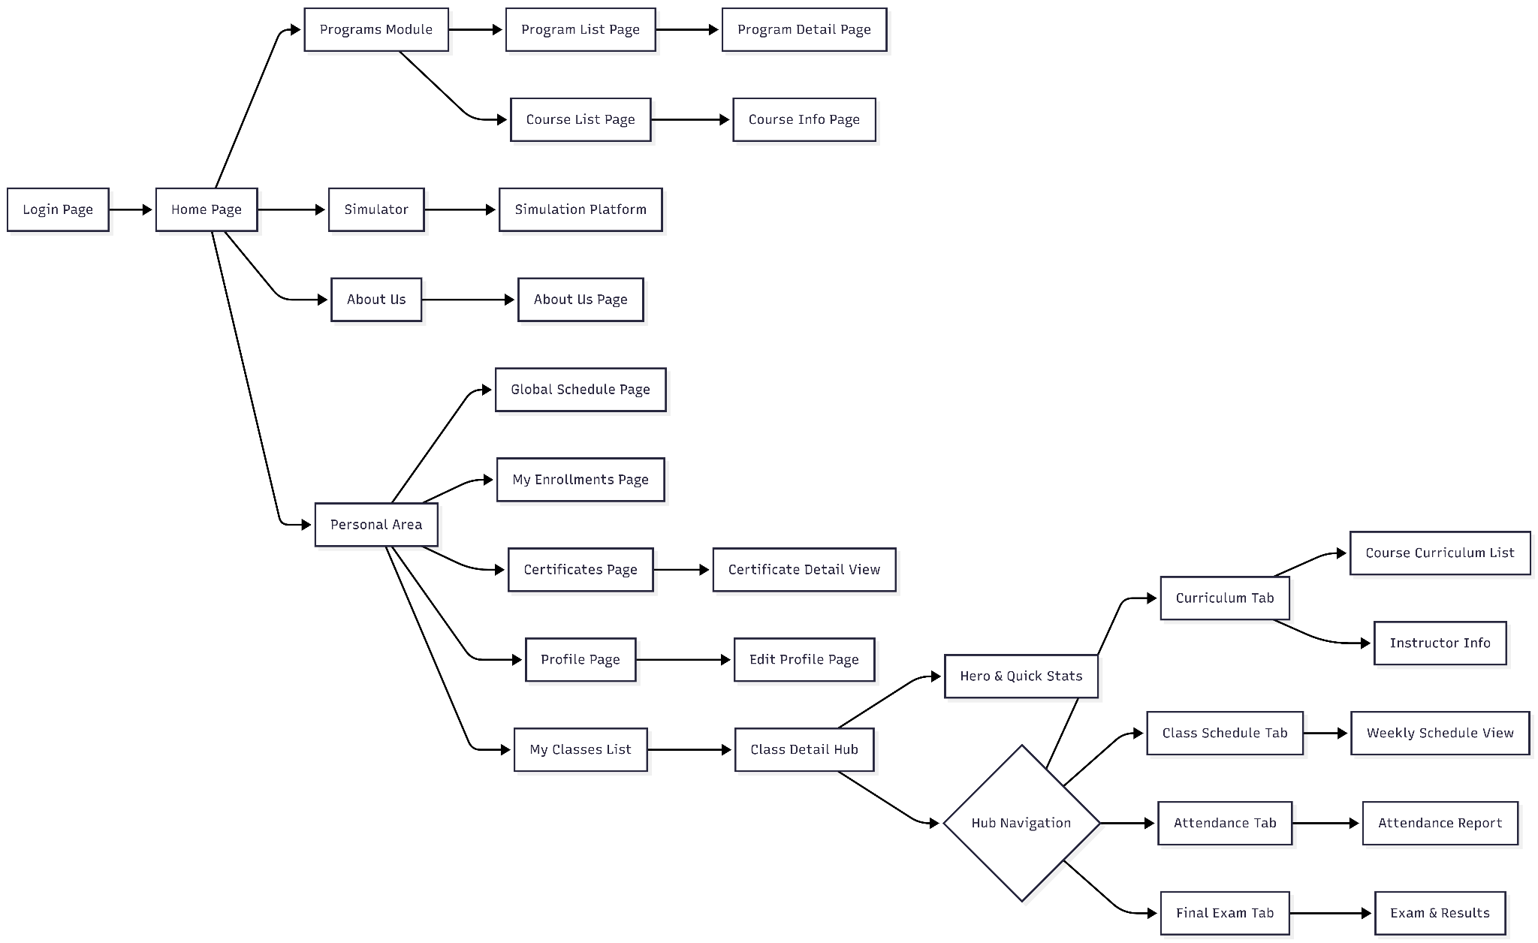

3.1.1.2 Instructor Flow
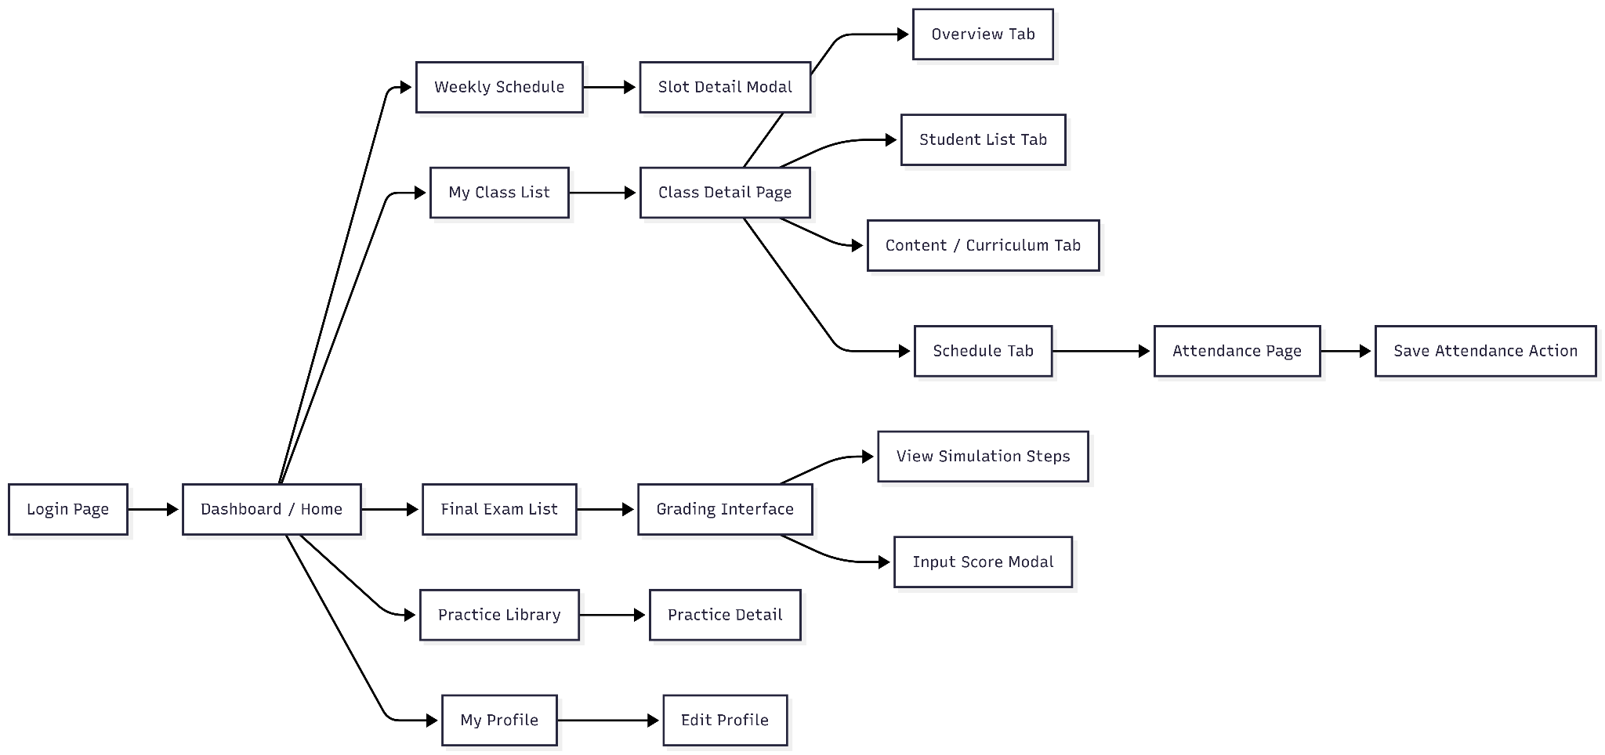

3.1.1.2 Simulation Manager Flow
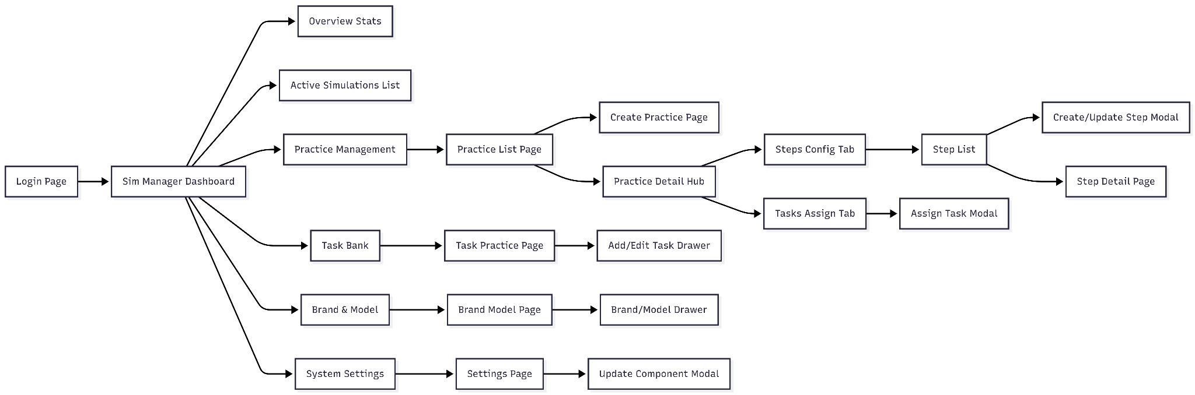

3.1.2 Screen Descriptions

# | Feature | Screen | Description
1 | Authentication | Login Screen | Allows users (Admin, Instructor, Trainee, Sim Manager) to log into the system using Email/Password or Google OAuth. Supports a link to the "Forgot Password" page.
2 | Authentication | Forgot Password Screen | Allows users to request a password reset via email verification and enter a new password.
3 | Common | Landing Page / Home | Introductory page for the training center, displaying featured courses, featured instructors, and related news. Visible to unauthenticated users or Trainees.
4 | Common | User Profile Screen | Allows users to view and update personal information, profile pictures, and change their password.
5 | Admin | Admin Dashboard | Displays a statistical overview of the system: total users, class statuses, course completion rates, and role distribution charts.
6 | Admin | User Management Screen | Lists all users in the system. Admins can add new users, edit details, disable accounts, or Import lists from Excel files.
7 | Admin | Program Management Screen | Manages training programs (frameworks). Allows creating new programs, assigning courses to programs, and setting up hierarchical structures.
8 | Admin | Course Management Screen | Manages the list of courses. Admins can create new courses, set up content (Sections, Lessons), upload learning materials, and configure Quizzes.
9 | Admin | Class Management Screen | Manages active classes. Allows creating classes based on courses, scheduling sessions, assigning instructors, and adding trainees to classes.
10 | Admin | Certificate Template Screen | Allows Admins to design and manage certificate templates to be issued to trainees upon course completion.
11 | Instructor | Instructor Dashboard | Displays upcoming teaching schedules, statistics on the number of assigned classes, and the status of assignments/exams needing grading.
12 | Instructor | Teaching Schedule Screen | Displays a detailed weekly or monthly schedule of the instructor's teaching time slots.
13 | Instructor | My Classes Screen | Lists classes assigned to the instructor. Specific class details can be accessed from here for management.
14 | Instructor | Class Detail & Attendance Screen | Detailed management screen for a class: performing attendance checks per session, viewing the trainee list, and monitoring their learning progress.
15 | Instructor | Quiz & Question Bank Screen | Manages the multiple-choice question bank. Creates and configures Quizzes to assign to course content.
16 | Instructor | Grading Screen | Allows instructors to view trainee submissions/results (including theoretical exams and simulation results) and enter grades.
17 | Trainee | My Learning/Classes Screen | Displays the list of classes the trainee is enrolled in and the completion progress of each class.
18 | Trainee | Learning Player Screen | The main interface for trainees to watch video lectures, read PDF materials, or take Quizzes following the course curriculum.
19 | Trainee | Exam Taking Screen | Interface for taking multiple-choice exams (Final Exam/Quiz) with a countdown timer, question list, and submission function.
20 | Trainee | Simulation Platform | Integrated interface (WebGL/Unity) allowing trainees to practice crane operation in 3D directly in the browser. Displays guides, tasks, and records practice results.
21 | Trainee | Certificate View | Displays the digital certificate after the trainee completes a course, allowing for download or printing.
22 | Sim Manager | Simulation Dashboard | Statistics on simulation system usage, active Crane Models (Brand Models), and system performance.
23 | Sim Manager | Brand Model Management | Manages Crane Models, technical specifications, and related 3D assets for the simulation.
24 | Sim Manager | Practice Task Configuration | Configures practice scenarios, defining execution steps, pass/fail conditions, and automatic grading criteria for the simulation system.

3.1.3 Screen Authorization

# | Screen Name (Tên màn hình) | Guest | Admin | Instructor | Trainee | Sim Manager
1 | Landing Page / Home | x | x | x | x | x
2 | Login Screen | x
3 | Forgot Password Screen | x
4 | User Profile Screen |  | x | x | x | x
5 | Admin Dashboard |  | x
6 | User Management Screen |  | x
7 | Program Management Screen |  | x
8 | Course Management Screen |  | x
9 | Class Management Screen |  | x
10 | Certificate Template Screen |  | x
11 | Instructor Dashboard |  |  | x
12 | Teaching Schedule Screen |  |  | x
13 | My Classes Screen (Instructor) |  |  | x
14 | Class Detail & Attendance Screen |  |  | x
15 | Quiz & Question Bank Screen |  |  | x
16 | Grading Screen |  |  | x
17 | My Learning/Classes Screen (Trainee) |  |  |  | x
18 | Learning Player Screen |  |  |  | x
19 | Exam Taking Screen |  |  |  | x
20 | Simulation Platform (3D) |  |  |  | x
21 | Certificate View |  |  |  | x
22 | Simulation Dashboard |  |  |  |  | x
23 | Brand Model Management |  |  |  |  | x
24 | Practice Task Configuration |  |  |  |  | x

3.1.4 Non-Screen Functions

# | Function Name | Trigger Event | Description
1 | JWT Token Management | User login or API request. | Generates Access Tokens and Refresh Tokens containing user claims and roles. Validates token signature and expiration on every incoming HTTP request to ensure secure access.
2 | Password Hashing | User registration or password change. | Secures user passwords using HMACSHA512 hashing algorithms with unique salts before storing them in the database, preventing plain-text storage.
3 | Google OAuth Validation | "Login with Google" action. | Communicates directly with Google APIs to validate the IdToken received from the client, retrieving user profile information to authenticate or register the user automatically.
4 | Email Notification Service | Forgot Password request or System Alerts. | Generates dynamic HTML email content (e.g., OTP codes) and dispatches emails to users via an SMTP server configuration.
5 | Excel Data Import Processor | Admin uploads an Excel file. | Parses binary Excel files (.xlsx) to bulk import complex data structures such as User lists, Quiz Question banks, and Training Programs into the database.
6 | Cloud Storage Integration | User uploads media (Avatar, Materials). | Handles file uploads to Firebase Storage. It manages file naming to prevent conflicts and generates public download URLs for storage in the database.
7 | Auto-Grading Engine | Trainee submits a Quiz or Simulation task. | For Quizzes: Compares user answers with the answer key, calculates the final score, and determines Pass/Fail status.  For Simulation: Processes JSON telemetry data from the simulation client to evaluate safety violations and execution time.
8 | Class Status Automation | Scheduled task or Data change. | Automatically evaluates class schedules and progress to transition class statuses (e.g., automatically marking a class as Completed when the end date is passed and requirements are met).
9 | Data Cleanup Service | Scheduled maintenance. | Identifies and removes orphaned records, temporary files, or soft-deleted data to optimize database performance and storage usage.

3.1.5 Entity Relationship Diagram

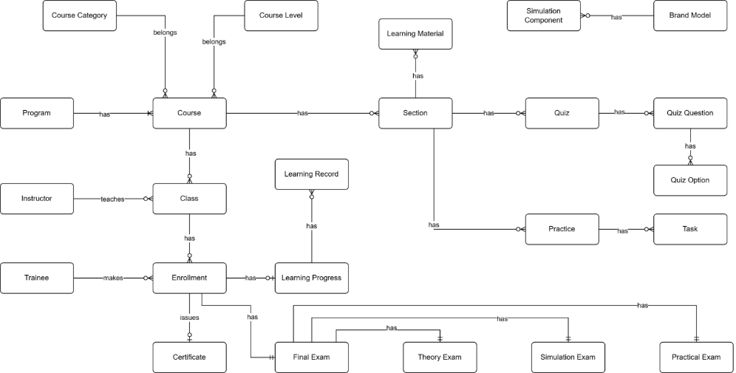

Entities Description
# | Entity | Description
1 | Course Category | Classification or categorization of courses by subject area or domain (e.g., Basic Crane Operations, Safety Procedures, Advanced Techniques). Provides organizational structure for grouping related courses. Each course belongs to one category.
2 | Course Level | Defines the difficulty or skill level of a course (e.g., Entry Level, Intermediate, Advanced). Used to establish learning progression paths and prerequisite requirements. Each course is assigned one level to indicate target trainee proficiency.
3 | Program | Comprehensive training program consisting of multiple courses designed to achieve specific certification or skill objectives. Programs define structured learning paths for trainees, combining courses in a logical sequence to build competencies for crane operator certification.
4 | Course | Individual training course representing a specific subject or skill area within the crane training curriculum. Contains course content structured into sections, can be assigned to multiple programs, and serves as the foundation for class creation. Belongs to one category and one level.
5 | Instructor | Teaching staff member responsible for delivering course instruction, managing class activities, creating learning materials and assessments, and evaluating trainee performance. Instructors are assigned to teach specific classes and provide guidance throughout the learning process.
6 | Class | Scheduled instance of a course with defined start/end dates, assigned instructor, and enrolled trainees. Represents the actual delivery of course content to a specific group of trainees. Classes are where learning activities, assessments, and instruction occur.
7 | Trainee | Student or learner enrolled in training programs to become certified crane operators. Trainees make enrollments in classes, access learning materials, complete quizzes and practices, take final exams, and track their learning progress toward certification.
8 | Enrollment | Record of a trainee's registration in a specific class. Creates the relationship between trainee and class, enabling access to course materials, activities, and assessments. Enrollment triggers creation of learning progress tracking and final exam records.
9 | Learning Material | Educational content resources such as videos, documents, presentations, or external links used to deliver course instruction. Materials are assigned to sections to provide trainees with reference and study resources. Can be reused across multiple sections.
10 | Section | Logical unit or module within a course syllabus representing a specific topic or learning objective. Sections organize course content into manageable chunks and contain learning materials, quizzes, and practices. Defines the structure and sequence of course curriculum.
11 | Quiz | Assessment tool containing multiple questions used to evaluate trainee understanding of theoretical concepts. Quizzes are assigned to sections, have defined pass criteria and time limits, and contribute to overall learning progress. Results are tracked through quiz attempts.
12 | Quiz Question | Individual question within a quiz presenting a problem or prompt for trainees to answer. Questions are assigned point values (contributing to total quiz score of 10 points) and can support single or multiple correct answers through associated quiz options.
13 | Quiz Option | Possible answer choice for a quiz question. Each option is marked as correct or incorrect and may have associated explanations. Multiple options per question enable various question types (multiple choice, select all that apply).
14 | Practice | Simulation-based training scenario performed in the 3D crane simulator environment. Practices consist of ordered tasks that trainees must complete to demonstrate hands-on skills. Assigned to sections as practical learning activities with defined difficulty levels and attempt limits.
15 | Task | Individual step or action within a simulation practice that trainees must perform correctly. Tasks define expected results for validation, and task completion is tracked during practice attempts. Tasks are reusable components across different practices.
16 | Simulation Component | 3D virtual representation of crane parts, controls, or environment objects used in simulation practices. Components are linked to brand models to represent real-world equipment and are referenced in tasks for interaction requirements.
17 | Brand Model | Specification of real crane equipment brands and models being simulated in the training system. Defines manufacturer information, specifications, and links to simulation components that represent the physical equipment in virtual environment.
18 | Learning Record | Historical record of trainee interactions with course sections, tracking what content has been accessed and when. Maintains audit trail of learning activities for compliance, reporting, and progress monitoring purposes.
19 | Learning Progress | Comprehensive tracking of trainee advancement through enrolled courses. Records overall progress percentage, theory and practical scores, completion status, and timestamps. Central entity for monitoring trainee performance and determining certification readiness.
20 | Certificate | Official document template awarded to trainees upon successful course or program completion. Defines certificate design, content structure, and requirements. Issued certificates are permanent records of trainee achievement for verification and credentialing purposes.
21 | Final Exam | Comprehensive assessment conducted at course completion to evaluate trainee readiness for certification. Consists of three components (Theory, Practical, Simulation) that are weighted and combined for total score. Results determine pass/fail status and certificate eligibility.
22 | Theory Exam | Written assessment component of final exam evaluating trainee understanding of theoretical concepts and safety knowledge. Implemented using the quiz system with defined pass criteria. One of three partial exams that compose the final exam.
23 | Simulation Exam | Performance-based assessment component conducted in 3D simulator requiring trainees to demonstrate crane operation skills. Uses practice system with task-by-task evaluation. One of three partial exams contributing to final exam score and certification decision.
24 | Practical Exam | Hands-on assessment component where trainees demonstrate physical crane operation skills evaluated by instructors using predefined checklists. Assesses real-world competencies beyond simulation environment. One of three partial exams required for certification.

3.2 Feature 1: Trainee Learning & Progress Tracking

3.2.1 Description
This is the core functional area for Trainees. It provides an interactive Learning Management System (LMS) interface where trainees perform their daily training activities. The system delivers multimedia content (Videos, PDFs), conducts assessments (Quizzes), and provides specifications for Simulation tasks. Crucially, it tracks the trainee's progress in real-time, ensuring they follow the structured curriculum path defined by the administration.
3.2.2 Functional Requirements

ID | Requirement Name | Description
FR-LRN-01 | Access My Classes | Trainees can view a list of all classes they are currently enrolled in, along with the current completion percentage and status (OnGoing, Completed) for each class.
FR-LRN-02 | View Course Curriculum | Within a class, the system displays the full hierarchy of the course: Sections (Modules) and Activities (Lessons). It indicates which activities are completed, in progress, or locked.
FR-LRN-03 | Multimedia Player | The system provides an embedded player to view MP4 video lectures and a PDF viewer for reading training manuals and safety guidelines directly within the browser.
FR-LRN-04 | Take Section Quizzes | Trainees can attempt quizzes assigned to specific sections. The system records the attempts, scores, and pass/fail status. Infinite or limited retakes are enforced based on configuration.
FR-LRN-05 | Simulation Task Guidance | For simulation activities, the web portal displays the task objectives, step-by-step instructions, and passing criteria (e.g., "Move container A to B within 5 minutes"), guiding the trainee before they enter the 3D simulator.
FR-LRN-06 | Automatic Progress Tracking | The system automatically marks activities as "Completed" when specific conditions are met (e.g., video watched 90%, PDF scrolled to bottom, Quiz passed).
FR-LRN-07 | Sequential Learning Enforcement | The system enforces a linear learning path (if configured), locking subsequent sections until the trainee has completed the prerequisite activities in the current section.
FR-LRN-08 | View Personal Profile & History | Trainees can view their own activity history, including past quiz scores, simulation practice results, and attendance records.

3.2.3 Screen Flow & UI Components
The learning experience involves two primary screens:
- My Learning Screen (Dashboard):
  - UI: A grid view of ClassCard components.
  - Information: Class Name, Course Code, Instructor Name, Progress Bar (visual indicator of completion), and "Continue Learning" button.
- Learning Player Screen (The Classroom):
  - Layout: A split-screen layout (Sidebar on the left, Content Area on the right).
  - Sidebar: Displays the CourseSection list (Accordion style). Icons indicate the type of activity (Video, Doc, Quiz) and its status (Green Check for done, Lock icon for locked).
  - Content Area:
    - Video: Uses a custom video player wrapper (VideoContent.jsx).
    - Document: Embeds a PDF viewer (ReadingContent.jsx).
    - Quiz: Renders the quiz interface (QuizContent.jsx) with question navigation.
    - Practice: Shows simulation task details and history of attempts (PracticeContent.jsx).

3.2.4 Backend Implementation Logic
The backend manages state tracking and content delivery:
- Controllers:
  - ProgressController: Aggregates data to calculate the overall percentage (LearningProgress).
  - ActivityRecordsController: Handles the granular status of each item (e.g., POST /api/activity-records to mark a video as watched).
  - SectionRecordsController: Monitors the completion of entire sections to unlock new content.
- Entities:
  - ActivityRecord: The pivotal entity linking a Trainee, a Class, and a specific Activity. It stores Status (Completed/Incomplete) and timestamps.
  - LearningMaterial: Stores the URL (Firebase) and metadata for the content.
- Business Logic:
  - Progress Calculation: ProgressesService.cs calculates progress as: (Count of Completed Activities / Total Activities in Course) * 100.
  - State Transition: When a Trainee passes a Quiz, the QuizAttemptsService triggers an update to the ActivityRecord, setting it to Completed.
  - Security: Content URLs are often signed or verified to prevent unauthorized access outside the learning platform.

3.3 Feature 2: Trainee Simulation Practice

3.3.1 Description
This feature bridges the gap between theoretical knowledge and real-world application. It allows Trainees to engage in practical crane operation exercises within a safe, physics-based 3D virtual environment. Unlike the Final Exam, these practices are part of the regular course curriculum (Learning Path). The system provides detailed scenario guides, tracks every movement and safety violation (collisions, dangerous swaying), and provides immediate automated grading and feedback.
3.3.2 Functional Requirements

ID | Requirement Name | Description
FR-SIM-01 | View Practice Objectives | Before starting, the Trainee can view the specific tasks required for the session (e.g., "Lift the red container," "Navigate through the obstacle course") and the criteria for passing (e.g., "Complete within 10 minutes").
FR-SIM-02 | Launch Simulation | The system initializes the 3D simulation environment directly within the browser (WebGL) or authenticates the user into a desktop client using a generated session token.
FR-SIM-03 | Real-time Telemetry Tracking | While practicing, the simulation client tracks critical metrics: execution time, collision counts (crane-to-obstacle, load-to-ground), and limit switch violations.
FR-SIM-04 | Step-by-Step Guidance | The system highlights the active task in the UI (e.g., "Step 1: Move to Point A"), updating automatically as the trainee completes actions in the 3D world.
FR-SIM-05 | Automatic Submission & Grading | Upon finishing the scenario or running out of time, the system automatically submits the performance data. The backend calculates a score (0-100) based on pre-defined penalties for safety violations.
FR-SIM-06 | View Attempt History | Trainees can view a history of their attempts for a specific practice module, allowing them to track improvement in their scores and completion times over multiple tries.
FR-SIM-07 | Safety Violation Alerts | Immediate visual feedback is provided in the simulation HUD (Heads-Up Display) if a safety rule is violated (e.g., "Warning: Load Swinging").

3.3.3 Screen Flow & UI Components
The feature utilizes an integrated approach within the Learning Player:
- Practice Overview Screen (LMS View):
  - Location: Inside the Learning Player Screen (see Feature 5).
  - Components:
    - Task List: Displays the sequence of PracticeTask items.
    - Stats Panel: Shows Allowed Time, Max Score, and Passing Score.
    - History Table: Uses PracticeAttemptsHistory.jsx to list previous attempts (Date, Duration, Score, Status).
    - Action: "Start Practice" button launches the simulation.
- Simulation Platform Screen (Active State):
  - UI: Full-screen or embedded 3D Canvas (SimulationPlatform.jsx).
  - HUD Elements:
    - Dashboard: Shows simulated crane indicators (wind speed, load weight, boom angle).
    - Notifications: Pop-ups for successful step completion or errors.
    - Controls: On-screen controls (if no hardware joystick is connected) or mapping overlay.

3.3.4 Backend Implementation Logic
The backend acts as the authoritative judge for the simulation results:
- Controllers:
  - PracticesController: Retrieves the scenario configuration (start positions, target zones) to initialize the 3D world.
  - PracticeAttemptsController: Handles the start (POST /start) and submission (POST /submit) of practice sessions.
- Entities:
  - Practice: Stores the metadata of the exercise.
  - PracticeTask: Defines the individual steps (e.g., "Lift", "Move", "Place").
  - PracticeAttempt: Stores the result of a single session.
- Grading Algorithm (PracticeAttemptsService.cs):
  - The system receives a SubmitPracticeTaskDto containing telemetry.
  - Base Score: Starts at 100 (or max defined).
  - Deductions: Subtracts points for:
    - Collisions (Severity * Penalty Weight).
    - Time Overrun (Time exceeded * Penalty per second).
    - Dangerous Operations (e.g., moving while load is too low).
  - Pass/Fail: Updates the ActivityRecord status based on whether the final score meets the PassScore threshold.

3.4 Feature 3: Program & Course Management

3.4.1 Description
This feature serves as the academic backbone of the LSSCTC system. It empowers Administrators to construct and organize the educational hierarchy. The system allows for the creation of Training Programs (curriculum frameworks) and individual Courses. Furthermore, it enables the detailed structuring of course content into Sections and specific Activities (Lessons, Videos, PDFs, Quizzes), effectively digitizing the crane training curriculum.
3.4.2 Functional Requirements

ID | Requirement Name | Description
FR-PROG-01 | Manage Training Programs | Admins can create, update, delete, and view Training Programs. A program acts as a container for multiple related courses (e.g., "Basic Crane Operation Program").
FR-PROG-02 | Program Hierarchy & Assignment | The system allows Admins to assign specific Courses to a Program. It maintains the relationship between programs and courses to structure the learning path.
FR-COURSE-01 | Manage Courses | Admins can manage the lifecycle of a Course, defining its title, description, level (Beginner/Intermediate/Advanced), and category.
FR-COURSE-02 | Curriculum Builder | The system provides an interface to structure a Course into Sections (Modules) and Activities (Lessons). Admins can arrange the order of learning content.
FR-MAT-01 | Learning Materials Management | Admins can upload and manage digital learning resources. Supported formats include PDF documents for reading and MP4 videos for lectures.
FR-MAT-02 | Cloud Storage Integration | The system integrates with Firebase Storage to securely upload and serve large media files (videos/documents), ensuring scalability and fast access.
FR-QUIZ-01 | Quiz Assignment | Admins can attach Quizzes (created in the Quiz Management feature) to specific sections within a course to assess trainee understanding.
FR-IMP-01 | Bulk Import Programs | The system supports importing complex program structures (Program -> Course -> Section) via Excel files to speed up initial data entry.

3.4.3 Screen Flow & UI Components
The management flow involves the following key screens:
- Program Management Screen:
  - UI: A list view of existing programs with options to "Add New Program" or "Import from Excel".
  - Action: Clicking on a program redirects to the Program Detail View, where linked courses are listed.
- Course Management Screen:
  - UI: Displays a catalog of all courses. Filters available by Category and Status (Active/Inactive).
  - Components: "Create Course" modal collecting basic info (Name, Code, Image).
- Course Detail & Curriculum Editor:
  - UI: A hierarchical view (often an Accordion or Tree view) displaying Sections.
  - Actions:
    - Add Section: Create a new topic/module.
    - Add Activity: Within a section, the Admin selects the type of activity: Video, PDF, or Quiz.
    - Upload: Drag-and-drop zone for uploading course materials.

3.4.4 Backend Implementation Logic
The backend handles the hierarchical data structure and file operations:
- Controllers:
  - ProgramsController: Manages the high-level program entities.
  - CoursesController: Handles course metadata.
  - SectionsController: Manages the subdivisions within a course.
  - MaterialsController & ActivitiesController: Handle the specific learning content.
- Services & Patterns:
  - Onion Architecture: Separates the domain entities (TrainingProgram, Course, Section) from the business logic.
  - Firebase Storage Service: The FirebaseStorageService.cs is invoked when uploading course materials. It returns a public URL which is then stored in the SQL Database.
  - Import Logic: ProgramImportService.cs uses NPOI to parse Excel files, automatically creating the necessary database relationships (Program-Course-Section) in a single transaction.
- Data Integrity:
  - The system enforces foreign key constraints to ensure that if a Course is deleted, related Enrollments or Sections are handled appropriately (Soft Delete pattern).

3.5 Feature 4: Trainee Final Examination (TE, SE, PE)

3.5.1 Description
The Final Examination feature is the culmination of the training process. To ensure comprehensive competency, the system evaluates Trainees through three distinct Final Exam Partials:
- Theory Exam (TE): A computer-based multiple-choice test with a strict time limit.
- Simulation Exam (SE): A practical test performed in the 3D Simulation Platform, graded automatically by the system based on safety and precision.
- Practical Exam (PE): An offline, real-world crane operation test graded by an Instructor using a digital checklist.
The system aggregates scores from these three partials based on pre-configured weights to determine the final Pass/Fail status.
3.5.2 Functional Requirements

ID | Requirement Name | Description
FR-EXAM-01 | View Exam Structure | The Trainee can view the Final Exam dashboard, which lists the three partials (TE, SE, PE), their current status (Locked, Open, Completed), and their weightage (e.g., 30%, 40%, 30%).
FR-EXAM-02 | Take Theory Exam (TE) | The system allows the Trainee to start the TE. The interface enables answering questions, flagging questions for review, and navigating between questions.
FR-EXAM-03 | TE Timer Enforcement | A server-side and client-side countdown timer enforces the exam duration. The system automatically submits the exam when the timer reaches zero.
FR-EXAM-04 | TE Auto-Grading | Upon submission, the system immediately calculates the score based on the answer key stored in the database and updates the TE status to "Completed".
FR-EXAM-05 | Generate Simulation Code (SE) | To take the Simulation Exam, the Trainee must request a unique, time-sensitive Exam Code via the web portal. This code is used to authenticate within the separate 3D Simulation Client.
FR-EXAM-06 | Process Simulation Results | The system receives telemetry data (collisions, time taken, load handling) from the 3D Client, calculates a score (0-100), and updates the SE record in the web portal.
FR-EXAM-07 | View Practical Results (PE) | Trainees cannot "take" the PE online. Instead, they view the grades and feedback checklist submitted by the Instructor after their real-world assessment.
FR-EXAM-08 | Final Grading Calculation | Once all partials are graded, the system calculates the weighted average. If the score meets the threshold, the Final Exam status is updated to Passed.

3.5.3 Screen Flow & UI Components
The examination flow is managed through the Final Exam Dashboard and specific execution screens:
- Final Exam Dashboard:
  - UI: A tabbed interface (IndustrialTabs) separating TE, SE, and PE.
  - Information: Displays current score, status badge (e.g., "In Progress"), and "Start" buttons (if applicable).
  - Logic: Locks specific tabs if the Class Schedule indicates the exam date has not arrived.
- Exam Taking Screen (TE):
  - Components:
    - Header: Countdown Timer (HeaderTimer.jsx), Progress Bar.
    - Body: Question Text, Option Radio Buttons (QuestionCard.jsx).
    - Sidebar: Grid of question numbers color-coded by status (Answered, Flagged, Unseen) (QuestionSidebar.jsx).
  - Action: "Submit Exam" button triggers a confirmation modal (SubmitModal.jsx).
- Simulation Exam View (SE):
  - UI: Informational card explaining the scenario.
  - Action: "Generate Exam Code" button.
  - Display: Shows the 6-digit code needed to login to the Unity Simulation.
- Exam Result View:
  - UI: Shows the score (e.g., "85/100"), the outcome ("Passed"), and a breakdown of correct/incorrect answers (for TE).

3.5.4 Backend Implementation Logic
The backend uses a complex relational structure to manage these diverse exam types:
- Entities:
  - FinalExam: The root entity linking a Trainee to a Class.
  - FinalExamPartial: Represents the specific instance of a TE, SE, or PE.
  - FeTheory: Stores specific data for TE (Quiz ID, Answers).
  - FeSimulation: Stores specific data for SE (Exam Code, Safety Violations).
  - PeChecklist: Stores the Instructor's evaluation for PE.
- Services (Lssctc.ProgramManagement):
  - FEService.cs: The orchestrator. It checks if the trainee is eligible to take the exam (Enrollment Status = Approved) and aggregates the final result.
  - FEPartialService.cs: Manages the lifecycle of a specific partial (e.g., checking if EndTime has passed).
  - SEService.cs: Specifically handles the logic for Simulation. It generates a random alphanumeric code and stores it in the FeSimulation table. When the 3D Client sends results, this service validates the code and saves the score.
  - QuizAttemptsService.cs: Reused for the Theory Exam to handle question randomization and scoring logic.
- Safety & Integrity:
  - TE: Preventing "tab switching" or multiple submissions is handled via browser events and backend validation of IsSubmitted flags.
  - SE: The Exam Code is valid only for a specific TimeSlot, preventing trainees from practicing simulations at home and counting it as an exam.

4. Non-Functional Requirements

4.1 Security
- NFR-SEC-01 (Authentication Mechanism): The system must utilize JWT (JSON Web Tokens) for stateless authentication. All protected API endpoints must validate the Bearer token in the HTTP Authorization header to ensure secure access without server-side session storage.
- NFR-SEC-02 (Identity Integration - SSO): The system must integrate with Google Identity Platform via OAuth 2.0 (GoogleOAuthService), enabling users to securely authenticate using their existing Google accounts without storing raw credentials in the system database.
- NFR-SEC-03 (Data Protection): Sensitive user data, specifically local passwords, must be hashed using strong cryptographic algorithms (e.g., BCrypt or PBKDF2 implemented in PasswordHashHandler) before storage.
- NFR-SEC-04 (Access Control): The API must enforce strict Role-Based Authorization (RBAC) at the Controller level. Users (Admin, Staff, Instructor, Trainee) are restricted to accessing only resources and actions explicitly permitted for their role.
- NFR-SEC-05 (Input Validation): All API inputs must undergo strict server-side validation (using Data Annotations or Fluent Validation in DTOs) to prevent injection attacks and ensure data consistency before processing.

4.2 Performance & Scalability
- NFR-PERF-01 (Asynchronous Processing): All I/O-bound operations (Database queries, File Uploads, Email Services) must use Asynchronous Patterns (async/await) to prevent thread blocking and maximize server throughput under high concurrency.
- NFR-PERF-02 (Server-Side Pagination): To optimize response time and bandwidth, all API endpoints returning collections (e.g., Class Lists, Question Banks) must implement Server-Side Pagination (PagedResult), limiting the default page size (e.g., 10-50 items).
- NFR-PERF-03 (Cloud Storage Strategy): The system must strictly offload binary files (images, videos, documents) to Firebase Cloud Storage. The application server shall only store the file URL/metadata, ensuring statelessness and horizontal scalability.
- NFR-PERF-04 (Database Optimization): Database queries must use projection (Select) to retrieve only necessary fields and utilize AsNoTracking() for read-only operations to reduce memory overhead in Entity Framework Core.

4.3 Availability & Reliability
- NFR-REL-01 (Global Error Handling): The Backend must implement a centralized Exception Handling Middleware (GlobalExceptionHandler). It must catch unhandled errors, log them internally, and return standardized JSON error responses to the client without exposing sensitive stack traces.
- NFR-REL-02 (Data Integrity - Soft Delete): Critical business entities (Users, Classes, Courses) must implement a "Soft Delete" mechanism (using IsDeleted flag) instead of permanent physical deletion to preserve historical data and maintain referential integrity.
- NFR-REL-03 (Transactional Integrity): Operations involving changes to multiple database tables (e.g., creating a class with assigned schedules) must be wrapped in a Database Transaction (UnitOfWork.Commit()) to ensure atomicity (all succeed or all fail).

4.4 Usability & User Experience
- NFR-UX-01 (Localization/i18n): The Frontend application must support Internationalization, enabling dynamic runtime switching between English (en) and Vietnamese (vi) locales without requiring a page reload (implemented via i18n libraries).
- NFR-UX-02 (Responsive Design): The Web Interface must be fully responsive, adapting its layout and functionality seamlessly across various viewports including Desktops (Admin/Instructor) and Tablets/Laptops (Trainees).
- NFR-UX-03 (User Feedback): The system must provide immediate visual feedback for user actions (e.g., Toast notifications for success/error, Loading spinners for asynchronous requests) to enhance perceived performance.

4.5 Maintainability & Interoperability
- NFR-MNT-01 (Architecture Pattern): The Backend system must adhere to Layered Architecture utilizing the Repository and Unit of Work Pattern (IGenericRepository, IUnitOfWork) to decouple business logic from data access, facilitating easier testing and future maintenance.
- NFR-INT-01 (API Standardization): The system must expose a RESTful API documented via Swagger/OpenAPI (v3), allowing seamless integration with the Frontend and potential third-party systems.
- NFR-INT-02 (Data Import/Export): The system must support interoperability with standard office formats, specifically enabling the bulk import/export of data (e.g., Quizzes, Student Lists) via Microsoft Excel (.xlsx) and CSV formats using dedicated processing services.

4.6 Deployment & Operational Requirements
- NFR-DEP-01 (CI/CD Automation): The system must utilize Continuous Integration and Continuous Deployment (CI/CD) pipelines (specifically GitHub Actions) to automate the build, test, and deployment processes, ensuring rapid and reliable delivery of updates to the production environment.
- NFR-DEP-02 (Cloud Infrastructure): The Frontend application must be hosted on a managed cloud service optimized for static web apps (e.g., Azure Static Web Apps), while the Backend API must be deployed on a scalable container or app service environment to ensure high availability.
- NFR-DEP-03 (Configuration Management): Application settings and sensitive secrets (Database strings, API Keys) must not be hardcoded. They must be managed via Environment Variables (appsettings.json overrides) to ensure security across Development, Staging, and Production environments.

5. Business Rules
ID | Category | Rule Definition
BR-01 | Authentication | Upon successful login to the web app, the system must redirect users to their role-based landing page:  - Admin: Admin Dashboard  - Simulation Manager: Simulation Manager Dashboard  - Instructor: Instructor Dashboard  - Trainee: Trainee Home Page
BR-02 | Authentication | Upon successful login to the simulation app, users with the 'Trainee' role must be redirected to the home screen.
BR-03 | Authentication | Deactivated accounts cannot log in or interact with the system.
BR-04 | Authentication | The Username, Email, and Phone Number fields must be unique for each user account.
BR-05 | Authentication | A user's Phone Number must be between 4 and 15 digits.
BR-06 | Authentication | The Email field must adhere to a standard email format (e.g., user@domain.com).
BR-07 | Authentication | A user's account profile can only be updated by the account owner.
BR-07 | Authentication | A password reset request must require email verification.
BR-08 | Permissions | The 'Admin' role has exclusive permissions to manage 'Simulation Manager', 'Instructor', and 'Trainee' accounts.
BR-09 | Permissions | The 'Admin' role has exclusive permissions to:  - Create and update programs.  - Assign courses to a program.  - Create and update courses.  - Create and update course syllabi.  - Manage classes.
BR-10 | Permissions | Instructors can only manage content for classes to which they are assigned.
BR-11 | Programs | A new program must be created with a Name and an Active Status.
BR-12 | Programs | A program cannot contain duplicate course assignments.
BR-13 | Programs | A program cannot be assigned more than 10 courses.
BR-14 | Courses | Each course must have a unique Name and a unique Course Code.
BR-15 | Courses | A new course must be created with a Name, Course Code.
BR-16 | Courses | A course’s learning section can only be updated if no classes are currently assigned to that course.
BR-17 | Classes | Each class must have a unique Name and a unique Class Code.
BR-18 | Classes | A class must be linked to a specific course upon creation.
BR-19 | Classes | A class must have exactly one assigned 'Instructor'.
BR-20 | Classes | Before a class starts, its learning content must mirror the learning sections of its parent course.
BR-21 | Classes | Class content can only be updated when class status is ‘Draft’ or ‘Open’.
BR-22 | Classes | A class can only be started if all conditions are met:  - At least one 'Trainee' is enrolled.  - One 'Instructor' is assigned only.  - Every class section contains at least one activity.
BR-23 | Classes | Each class must have a unique Name and a unique Class Code.
BR-24 | Trainee | A 'Trainee' must have a valid account before enrolling in any program.
BR-25 | Trainee | A 'Trainee' cannot be enrolled in the same class more than once.
BR-26 | Trainee | A 'Trainee' cannot be enrolled in two different classes that have conflicted schedules.
BR-27 | Trainee | 'Trainees' can only attempt quiz and practice when their session is valid.
BR-28 | Class Activities | Each learning activity must be one of the following types: 'Material', 'Quiz', or 'Practice'.
BR-29 | Class Activities | A new activity must be created with a Name, Type, and Order (sequence) number.
BR-30 | Class Activities | A new learning material (e.g., 'Video', 'Document') must include a Name and either a Source File or Source URL.
BR-31 | Class Activities | A Source File for learning material cannot exceed 50MB in size.
BR-32 | Quizzes | A new quiz must be created with a Name and a Max Attempts value.
BR-33 | Quizzes | A quiz must contain one or more questions.
BR-34 | Quizzes | Each question must include answer options, and each option must be flagged as 'Correct' or 'Incorrect'.
BR-35 | Quizzes | A quiz cannot contain more than 100 questions.
BR-36 | Quizzes | A quiz question cannot have more than 20 answer options.
BR-37 | Quizzes | The total score for every quiz must be exactly 10 points.
BR-38 | Quizzes | The score of any single question must be greater than 0 and less than 10.
BR-39 | Quizzes | The sum of all question scores within a quiz must equal 10.
BR-40 | Quizzes | Only users with the 'Trainee' role can attempt a quiz.
BR-41 | Quizzes | Every quiz attempt by a 'Trainee' must be recorded.
BR-42 | Quizzes | A 'Trainee's' final quiz score must be determined by their latest attempt.
BR-43 | Quizzes | 'Trainees' cannot retake a quiz after reaching the Max Attempts limit.
BR-44 | Simulation Practices | A simulation practice must contain between 1 and 20 tasks.
BR-45 | Simulation Practices | Each practice task must have a unique ‘task_code’.
BR-46 | Simulation Practices | Each practice must have a unique ‘practice_code’.
BR-47 | Simulation Practices | A task cannot be assigned to a practice more than once.
BR-48 | Simulation Practices | A new practice task must be created with a Name, Description, and Task Code.
BR-49 | Simulation Practices | A new simulation practice must have a unique Name and a unique Practice Code.
BR-50 | Simulation Practices | A new simulation Component must have a unique Name, and a unique Component Code.
BR-51 | Simulation Practices | 'Trainees' must be authenticated before accessing a simulation practice.
BR-52 | Simulation Practices | 'Trainees' can only start practices that are marked as 'Active' and are part of their assigned class.
BR-53 | Simulation Practices | 'Trainees' must complete all simulation tasks to finish a practice.
BR-54 | Simulation Practices | While a 'Trainee' is taking a simulation practice:  - The system must display guides and step descriptions.  - The system must automatically advance to the next step upon successful completion of the current step.  - The system must record the result of every step for evaluation.
BR-55 | Simulation Practices | 'Trainees' cannot retake a simulation practice after reaching the Max Attempts limit.
BR-56 | Simulation Practices | 'Trainees' must be authenticated before accessing a simulation practice.
BR-57 | Simulation Practices | 'Trainees' can only start a simulation final exam after input a correct Exam Code.
BR-58 | Simulation Practices | 'Trainees' can only access to the simulation final exam belongs to their enrolled classes.
BR-59 | Simulation Practices | While a 'Trainee' is taking a simulation final exam:  - The system must display guides and step descriptions.  - The system must automatically advance to the next task upon successful completion of the current step.  - The system must record the result of every task for evaluation.
BR-60 | Simulation Practices | 'Trainees' cannot retake a simulation final exam after reaching the Max Attempts limit.
BR-61 | Account Management | New user accounts registered via email must complete Email Verification (via OTP or Link) before access is granted.
BR-62 | Account Management | Users with a status of Inactive or Banned must be blocked from logging into the system immediately, regardless of valid credentials.
BR-63 | Class Management | A Class cannot be created or set to Open status if its parent Course does not have a complete structure (at least one Section, Activity, and associated Material/Quiz).
BR-64 | Class Management | The Class EndDate must be strictly greater than the StartDate. The StartDate cannot be set more than 30 days in the past.
BR-65 | Class Management | The Class Code must be unique across the entire system (case-insensitive) to prevent data conflicts.
BR-66 | Class Management | A Class can only transition from Draft to Open status if it has at least one assigned Instructor and at least one defined TimeSlot.
BR-67 | Class Management | The sum of grade weights (Theory, Practice, Final Exam) for any class must explicitly equal 100%.
BR-68 | Enrollment | Trainees can only self-enroll in classes that have the status Open. Enrollment is strictly disabled for classes in Draft, Closed, or Archived status.
BR-69 | Enrollment | The system must prevent enrollment if the current class size (count of Enrolled + Pending trainees) has reached the defined MaxCapacity.
BR-70 | Enrollment | A Trainee cannot enroll in a class if they already have an existing enrollment record with a status of Pending or Enrolled for that specific class.
BR-71 | Enrollment | Enrollment Status Default:  - Self-enrollment by Trainee defaults to Pending (requires approval).  - Manual addition by Staff/Instructor defaults to Enrolled (bypasses approval).
BR-72 | Scheduling | An Instructor cannot be assigned to two different classes that fulfill the Time Conflict condition (same Date and overlapping TimeSlot).
BR-73 | Learning Process | Access to specific learning materials or sessions is restricted based on Prerequisites (Sequential Locking: users must complete item A to unlock item B).
BR-74 | Examination | To start a strictly controlled assessment (e.g., Final Exam), the Trainee must input a valid, case-sensitive Exam Code provided by the Instructor.
BR-75 | Examination | Trainees are blocked from starting a Quiz or Practice session if their total attempts exceed the configured Max Attempts limit.
BR-76 | Examination | The Final Grade must be automatically recalculated by the system whenever a component score (Theory/Practice/Exam) is updated, based on the defined Class Weights.
BR-77 | Certificate Issuance | A Certificate is automatically issued to a Trainee only when all the following conditions are met:  1. The Class status is set to Closed.  2. The Trainee's attendance rate is $\ge$ the required threshold (e.g., 80%).  3. The Trainee's Final Grade is $\ge$ the Passing Score (e.g., 5.0/10.0).
BR-78 | Certificate Immutability | Once a Certificate is issued and a Certificate Number (License ID) is generated, it cannot be modified or deleted unless the entire Enrollment record is reset by an Administrator.
BR-79 | Grading Logic | Pass/Fail Determination: The system determines a Trainee's status based on the weighted sum of: (Theory Score * Weight) + (Practice Score * Weight) + (Final Exam Score * Weight). If the total is below the configured PassScore, the Trainee is marked as Failed.
BR-80 | Score Locking | Once an Instructor submits the grades for the "Final Exam" column and marks the status as Completed, the scores are locked (Read-only) and cannot be edited without an Admin explicitly reopening the grading session.
BR-81 | Material Restrictions | File Type Constraint: The system must restrict file uploads for Learning Materials to specific formats: .pdf for documents and .mp4 for videos. Executable files (.exe, .sh) are strictly prohibited for security.
BR-82 | Deletion Integrity | A Course cannot be deleted if it has any associated Classes (active or archived). Similarly, a Class cannot be deleted if it contains any enrolled Trainees. (Logic: Soft Delete or Block Delete).
BR-83 | Bulk Import Validation | When importing data (User, Course, or Class) via Excel/CSV:  1. The file structure must strictly match the system template.  2. If any row contains invalid data (e.g., invalid email format, duplicate code), the entire import batch must be rejected (Atomic Transaction) to prevent data inconsistency.
BR-84 | Simulation Access (Time) | Time-Based Access Control: Trainees can only access Practice Simulations when authorized via the ActivitySession check, typically enforcing access only within the assigned Class TimeSlots or active activity periods.
BR-85 | Self-Action Prevention | An Administrator cannot Delete or Ban their own account while logged in. They also cannot demote their own Role to a lower level.
BR-86 | Session Concurrency | (Security) If a User logs in successfully on a new device/browser, the system should invalidate the RefreshToken of previous sessions if the security policy requires single-session enforcement (Check JwtHandler logic).
BR-87 | Assessment Policy | Exam Weight Constraint: The sum of weight percentages for all assessment components (Theory, Practical, and Simulation) within a single Class must strictly equal 100%. The system shall prevent saving grading configurations if the total weight deviates from this value.
BR-87 | Scheduling | Instructor Conflict Check: An Instructor cannot be assigned to a Class TimeSlot if they are already scheduled for another Class during the same time interval. The system must validate instructor availability before confirming the assignment.
BR-88 | Enrollment | Trainee Schedule Conflict: A Trainee is prohibited from enrolling in a new Class if its schedule overlaps with any TimeSlots of their currently active Classes. The system must detect and block conflicting enrollments.
BR-89 | Grading Policy | Course Completion Criteria: A Trainee is considered to have "Completed" a course only if they meet both of the following conditions:  1. The Final Grade meets or exceeds the system-defined passing threshold (e.g., ≥ 5.0).  2. The Attendance Rate is within the allowable limit (e.g., Absence < 20%).
BR-90 | Security | Account Lockout Policy: To prevent brute-force attacks, the system shall temporarily lock a User account for a specific duration (e.g., 15 minutes) after 5 consecutive failed login attempts.
BR-91 | Assessment | Final Exam Eligibility: A Trainee is restricted from participating in the Final Exam if their Attendance Status is marked as "Banned" (due to excessive absence) or if they have not completed all mandatory prerequisite quizzes.
BR-92 | Data Integrity | Grade Immutability: Once a Class status transitions to "Closed" or "Archived," all associated Trainee grades and activity records shall become read-only. Instructors are restricted from modifying grades unless an Administrator explicitly re-opens the Class.
BR-93 | Enrollment | Class Capacity Limit: The system must automatically reject new enrollment requests for a Class once the count of enrolled Trainees reaches the defined MaxCapacity limit set during Class creation.
BR-94 | Assessment Configuration | Grading Weight Validation: The total weight percentage of all assessment components (Theory, Practical, and Simulation) within a specific Class must exactly equal 100%. The system shall prevent the Instructor or Admin from saving the configuration if the sum deviates from 100.
BR-95 | Data Integrity | Deletion Constraint for Active Entities: The system must restrict the deletion of any Course, Program, or Class if there are currently active Enrollments or associated Historical Data (e.g., Grades, Attendance records) linked to them to preserve data integrity.
BR-96 | Scheduling | Instructor Availability Check: An Instructor cannot be assigned to a specific TimeSlot in a Class Schedule if they are already assigned to another active Class during the same date and time range.
BR-97 | Authentication | Password Complexity Policy: User passwords must meet the following complexity requirements enforced by the backend Identity service: at least 8 characters long, containing at least one uppercase letter, one lowercase letter, one number, and one special character.
BR-98 | Course Management | Module Progression Logic: (If "Unlock" logic exists in code) A Trainee cannot access a specific Lesson or Quiz content unless they have completed the preceding required materials or passed the prerequisite items defined in the Course Structure.
BR-99 | System Administration | Role-Based Sensitive Action: Critical system actions, specifically "Hard Deleting" users or "Force Closing" a class manually, are strictly restricted to the Admin role and require a secondary confirmation prompt on the UI before execution.
BR-100 | Simulation | Attempt Limit Enforcement: For Simulation Exams (not free practice), the system must enforce a maximum number of attempts (e.g., 1 attempt for Final Exam) as configured in the FinalExamTemplate. Any further attempts must be blocked.
BR-101 | Reporting | Certificate Generation Condition: The system shall only generate a downloadable Certificate (PDF) for a Trainee when the Class Status is "Closed" and the Trainee's final status is marked as "Passed" based on the Grading Policy.
BR-102 | Simulation Access (Attempts) | Max Attempts Restriction: For Practice tasks designated with a MaxAttempts limit (e.g., Assessment Mode), the system must explicitly block any new attempt creation (CreatePracticeAttempt) once the Trainee's history count reaches this limit.
BR-103 | Simulation Access (Exam) | Final Exam Locking Mechanism: Access to Final Exam Simulations is blocked by default. It is only granted when two conditions are met:  1. The Instructor manually changes the Exam Status to "Open".  2. The current server date matches the scheduled Exam Start Date.

